**SETTING UP DEVELOPER ENVIRONMENT ON WINDOWS 11 – NOMBUSO NOKUKHANYA SIBIYA**

**Installing Windows 11**

* Check system requirements for Windows 11:
* Processor: 1 gigahertz (GHz) or faster with 2 or more cores on a compatible 64-bit processor or System on a Chip (SoC).
* RAM**:** 4 GB or more.
* Storage: 64 GB or larger storage device.
* TPM: Trusted Platform Module (TPM) version 2.0.
* Graphics Card: Compatible with DirectX 12 or later with a WDDM 2.0 driver.
* Display: High definition (720p) display that is greater than 9” diagonally, 8 bits per colour channel.

Go to [Download Windows 11 (microsoft.com)](https://www.microsoft.com/software-download/windows11) click on “Download Now” button.

Install Windows 11

* Run the Installation Assistant**:** Double-click on the downloaded Windows 11 Installation Assistant to start the installation process.
* Follow On-Screen Instructions**:** The assistant will guide you through the installation steps, including choosing installation options and partitioning your disk.
* Activate Windows**:** After installation, you may need to activate Windows 11 using your product key (if applicable).

After Windows 11 is installed, you can personalize your settings:

* Check for Updates**:** Go to Settings > Update & Security > Windows Update to ensure your system is up to date.
* Install Drivers**:** Update or install drivers for your hardware components (graphics card, network adapter, etc.)

**Download and install Visual Studio Code (VS Code)**

**For windows 11**

* Go to the Visual Studio Code website at <https://code.visualstudio.com/Download>.
* Select Your Operating System: Click on the download button for your operating system (Windows)
* Install Visual Studio choose options based on system architecture for 32-bit or 64-bit versions.
* Run the Installer: Once the download completes, locate the installer file (typically named VSCodeSetup.exe). Double-click the installer file to start the installation process.
* Follow Setup Wizard: Follow the prompts in the setup wizard. You can usually leave the default options selected unless you want to customize the installation location or create desktop shortcuts.
* Click "Next" through the screens to proceed with the installation.
* Launch Visual Studio Code: Once installation completes, you can launch Visual Studio Code by clicking on the newly created desktop shortcut or searching for "Visual Studio Code" in the Start menu.

**INSTALL GIT AND CONFIGURE IT ON YOUR LOCAL MACHINE, CREATE GITHUB ACCOUNT AND INITIALISE A GIT REPOSITORY**

Install Git

* Download Git: Visit the Git website: <https://git-scm.com/download/win>
* Run the installer (Git-*.exe).
* Follow the prompts in the installer. Use the default settings unless you have specific preferences.

Verify Installation:

* Open Git Bash (installed along with Git).
* Type git --version to verify that Git is installed and accessible from the command line.

Configure Git

* Open Git Bash
* Set your Git username
* Set Your Name and Email
* Check Configuration: You can check your Git configuration with

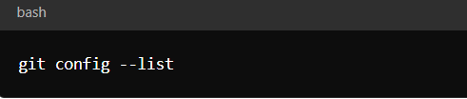

* Verify that your name and email are correctly set.

Create a GitHub Account

* Sign Up for GitHub: Go to [GitHub](https://github.com/) and sign up for a new account.
* Follow the instructions to create your account.

Initialize a Git Repository

* Create a new directory for your project

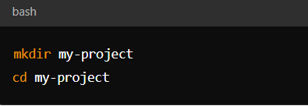

* Initialize a new Git repository in your project directory

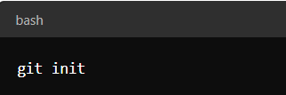

* Make Your First Commit
* Create a New File: Create a new file in your project directory (e.g., README.md):
* Add Files to Staging Area: Stage the file(s) for commit

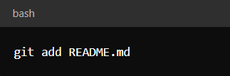

* Commit Changes: Commit the staged changes with a commit message:

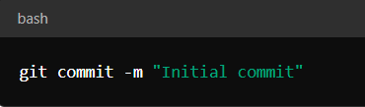

Connect Git Repository to GitHub

Create a New Repository on GitHub:

* Go to [GitHub](https://github.com/) and log in.
* Click on the "+" sign in the top right corner and select "New repository".
* Give your repository a name, choose visibility (public or private), and click "Create repository".

Add Remote Repository:

* Copy the URL of your newly created GitHub repository.
* Add the remote repository URL to your local Git repository:

Push Changes to GitHub:

* Push your local commits to the remote repository on GitHub

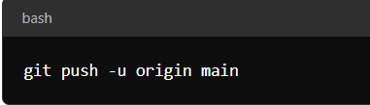

* This command sets the upstream main branch and pushes commits to GitHub.

**INSTALLING PYTHON**

Download Python

* Visit the Python Website: Go to the official Python website at <https://www.python.org>.
* Download Python Installer: Click on the "Downloads" menu at the top of the page.
* Choose the appropriate installer for your operating system (Windows, macOS, or Linux).
* For Windows, download the Windows installer (.exe file).

Install Python

Run the Installer:

* Double-click the downloaded .exe file to start the installation.
* Ensure to check the box that says "Add Python X.X to PATH" during the installation wizard.
* Click "Install Now" and follow the prompts to complete the installation.

Verify Installation:

* Open Command Prompt (cmd.exe) or PowerShell.
* Type python --version to verify that Python is installed and accessible from the command line.

Install Project Dependencies - Use pip to install dependencies:

* While in the activated virtual environment, install any Python libraries your project needs using pip:

Start Coding

Write and execute your Python code:

* Use your preferred text editor or IDE to create Python scripts.
* Run your Python scripts from the command line within the activated virtual environment

**Configure a Database (MySQL)**

Download MySQL Installer

Visit the MySQL Website: Go to the MySQL downloads page for Windows: [MySQL Installer for Windows](https://dev.mysql.com/downloads/windows/installer/5.7.html).

Download MySQL Installer:

* Scroll down to find the MySQL Installer for Windows section.
* Click on the "Download" button for the MySQL Installer appropriate for your system (32-bit or 64-bit).

Run the MySQL Installer - Start the Installation:

* Once the installer .exe file is downloaded, double-click it to start the installation process.

Choose Setup Type - When prompted, choose the setup type. Select "Developer Default" for a typical installation with necessary components like MySQL Server, MySQL Workbench, connectors, and other tools.

* Accept License Agreement

MySQL Server Configuration

MySQL Server Installation:

* In the MySQL Installer setup wizard, select "Server Only" or "Server and Client" depending on your needs. Usually, "Server Only" is sufficient for most installations.

Configure MySQL Server:

* Choose the installation type (e.g., Development, Server, Dedicated Server).
* Set up MySQL Server configuration parameters:
  + - Port number (default is 3306).
    - Root password: Set a secure password for the root user.

Advanced Configuration (Optional):

* Customize additional settings like server data directory, Windows service name, etc., or leave them as default.

Install MySQL Workbench:

* In the MySQL Installer setup wizard, select "MySQL Workbench" under Applications and Utilities.
* Follow the prompts to complete the installation of MySQL Workbench.

Execute Installation**:** Click "Next" to proceed with the installation process.

* Wait for Installation to Complete: The installer will download and install the selected MySQL components.
* Finish Installation: Once the installation completes, click on "Finish" to exit the installer.

Verify MySQL Installation - Check MySQL Server Installation:

* Open MySQL Workbench or Command Prompt (or PowerShell) and connect to the MySQL Server using the root credentials you set during installation.

Test Connection:

* Open MySQL Workbench.
* Enter the root username and password you set during installation.
* Click "Test Connection" to ensure MySQL Server is running correctly.